ST2612 Tutorial 5 (Week 14)

Recap of Practical 5, Lecture 6 (Part 1)

Learning objective of Practical 5:

* Understand the basic installation procedures and operational concepts of in-house centralized Windows Updates Services (e.g. WSUS).
  + Upstream and Downstream servers.
  + Product Catalog and Classifications.
  + Synchronization operations.
  + Computer Groups.
* Configure Group Policy for Windows Update.
* Hands on with WSUS management console
  + Approve specific update.
  + Test the WSUS update deployment life cycle of : Approve → download to server →

notify client -> download and install at client → report to WSUS of the status.

* + Viewing the various WSUS reports.

Lecture 6 (Part 1):

* Introduction to IPsec
  + IP Security Issues.
  + IPsec Concepts.
  + Advantages and applications of IPsec.
* IPsec Implementation
  + The 3 Security Control Elements of IPsec.
    - Internet key exchange IKE/IKEEXT.
    - Authentication Header (AH).
    - Encapsulating security payload (ESP).
  + IPsec Policies
    - Consist of one or more IPsec rules.
    - One or more can be defined at an Active Directory.
    - Each system can only deploy at most one IPsec Policy.
  + IPsec Rules
    - Each consists of 5 configurable elements.
* Understand the implications of deploying IPsec
  + CPU overhead.
  + Bandwidth overhead.
  + Connection time overhead.
  + IPsec Policies and deployment overhead.

Self-evaluation Check list

* List the two WSUS synchronization methods.
* Briefly describe one advantage of defining computer groups in WSUS management console.
* Would you briefly describe the 'relationship/difference' between the following lists of paired items?

-IKE authentication and AH authentication

-IPsec filter and IPsec rule

-IPsec Policies and Group Policies

* Would you describe and explain one possible but not recommended usage of IPsec?
* Would you identify and explain a couple of scenarios that the IPsec implementation can be helpful in terms of tighten the network security?
* Would you explain the following IPsec packet transformation?

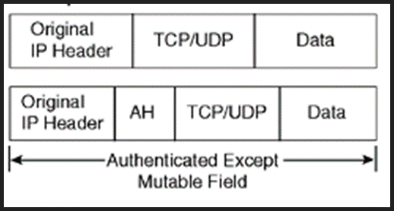

Nano Test Questions (Will be given by your tutor).

(For each attempted question: Correct answer earns 1 mark. Incorrect answer subtract 0.5 marks) (Maximum scores: 2 marks)

Q1.

Q2.

Q3. Q4

Submit your answers to the Nano Test Journal before the end of the class.

~ That's All ~